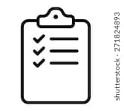
First Week of School Checklist
for Ms. De La Vega’s Class

- Filled out Parent Contact Form
- Joined Edmodo (find codes for each period on my website)
  - Username:
  - Password:
- Joined Khan Academy (find codes for each period on my website)
  - Username:
  - Password:
- Joined Quizizz (find links for each period on my website)
  - Username:
  - Password:
- Joined EdPuzzle (find codes for each period on my website)
  - Username:
  - Password:
- Completed Introduction to Online Learning Course

